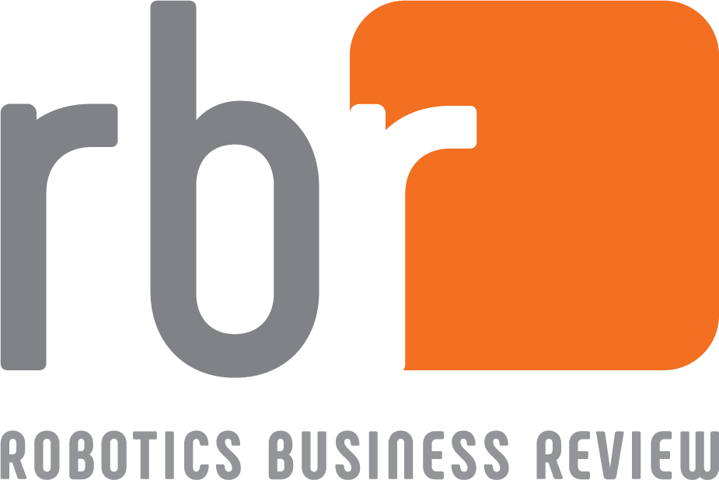

Robotics Business Review Start-Up Profile

Defining Robotics and Intelligent Systems Start-ups

To be listed, a company must meet the following criteria:

The company is working towards developing, deploying, and commercializing new robotics technologies, products, processes, or services.

Greater than 50% of the company’s business activities are attributable to producing robots or robotics enabling technologies, or providing services to robotics developers or end-users of robotics solutions.

The company has a run rate of less than US $25 million (forward 12 months).

The company has fewer than 50 employees.

The company is unfunded, or has received Seed, A or B funding rounds.

Instructions

Please respond to the following questions in the fields provided. The text insertion boxes will expand to accommodate entered text. Once you have completed the form (or if you have any questions), please Email to Dan Kara at dkara@wtwhmedia.com.

Company Overview
Company Name: | Enter company name. |  | Date: | Enter date.
City: | Enter location of company headquarters. | State: | Enter location of company headquarters.
Country: | Enter location of company headquarters. | # of Employees: | Enter number of employees.
URL: | Enter Company’s URL. | Founded: | Enter year company was founded.
Company’s Founders: | Enter the name of the company’s principals and their titles.
Funding Status: | Describe the company’s current funding status, and if the company is currently seeking investment.

Offerings Profile
Primary Target Markets: | Please choose three (3) primary target markets among the following:  Agriculture, Construction / Demolition, Consumer, Defense / Security, Healthcare / Medical, Logistics / Supply Chain, Manufacturing, Mining / Quarrying, Oil / Gas / Energy, Public Safety, Retail, Transportation, Utilities, Hospitality, Other
Technology /  Product /  Service(s): | What robotics technologies, products or services does the company offer?
Value Proposition: | What is the value proposition for the company’s technology/products/services? Ex. Lower cost compared to competitors, quick ROI, improved quality of goods, great customer service etc.
Demand Drivers: | What do you see are the demand drivers for the company’s technologies/products/services? Ex. Companies seeking to improve manufacturing productivity, reduce operational costs, developing closer relationship to customers, reducing worker injury, expanding into new market, increasing automation levels, etc.

Business Model(s) and Competitors
Business Model: | What is the company’s business model? Ex. Direct sales, working with distributors/integrators/partners, working with OEMs etc.
Partners: | Is the company working with any partners? If ‘Yes’, please elucidate and briefly describe.
Customers: | Can the company name any customers? If ‘Yes’, please elucidate and briefly describe.
Competitive Landscape: | Who are the company’s primary competitors? What companies are providing similar technologies, products, or services?

Recent News
Please enter the title of recent press releases or news items (up to 5), along with the URLs to their sources. Relevant topics include announcements of new partnerships, closed deals, management team hires, investment funding rounds, the opening of new offices etc.

